|  |
| --- |
|  |
| Logo Agire **DIADEME NEWS** |
|  |

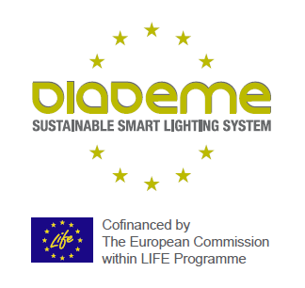

**Life DIADEME - Events 2019**

*Barcelona* Smart City Expo (Nov. '19)

*Rimini Ecomondo (Nov. '19)*

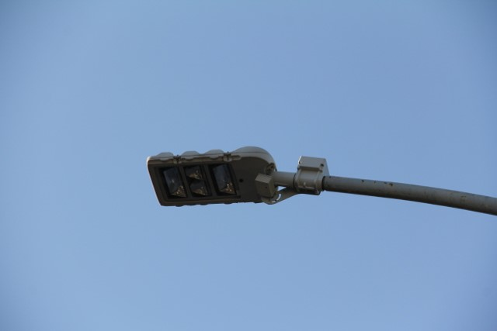

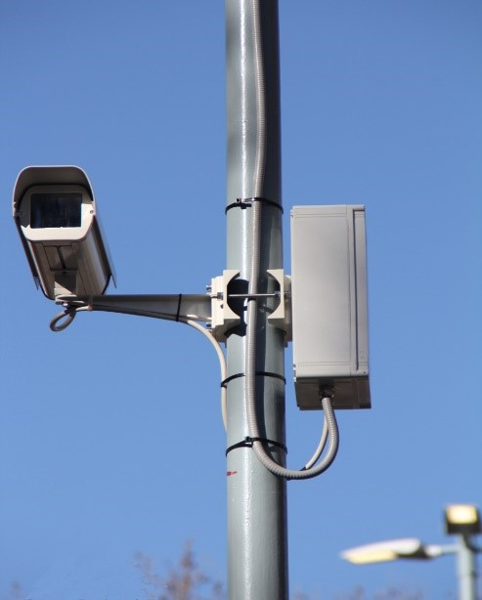

|  |
| --- |
| **DIADEME Large Test Site. Where we are**  Following the project forecast, the installation of the DIADEME Large Test Site in the streets of ROME, EUR quarter, began in early 2019. Out of a total of 1,000 light points to be equipped, in June about 70% of them were installed.  A picture containing scene, way, road, outdoor  Description automatically generatedBoth the Small Test Site, installed in 2018 and most of the Large Site systems have been properly tested and have already provided a data stream fully monitored and analysed.  The data analysis has been going on for months on an increasing number of light points and it seems to be enough clear that **DIADEME** is a **new and affordable system** dedicated to the **regulation of public lighting, adaptive and distributed, developed around UNI11248**. With the optimized utilization of distributed sensors to monitoring:   * traffic * luminance * noise * environmental gasses   **DIADEME system allows to ensure:**   * **remarkable energy saving** * **visual safety** * **reduction of CO2 emissions** * **reduction of maintenance costs**   The evolution of research on materials from the installation of the Small Site to the Large Site has led to a number of improvements that can be summarized as follows:   * size reduction of the appliances (70%) * utilization of the built-in box inside the Smart X-Tender * better positioning of sensors * Better connectivity with Air Quality devices * Redesigning of Air Quality box * Substantial costs reduction   The technical improvements during the implementation phase and a reduction in size and costs, combined with the advantages in terms of energy savings and emissions reduction gained, allow to be particularly optimistic concerning the **DIADEME System** and to suppose favourably a good and wide spread of the system once the project will be completed.    **Diademe "Project of the Month of February 2019" on the LIFE website of the Environment Ministry**  At present, a large part of energy consumption at European level depends on urban areas and generates significant greenhouse gas emissions (GHG).  Such consumption, as well as the worsening of air quality, are growing in the coming decades due to the increase in population and to the process of urbanization of metropolitan areas. Street lighting represents a substantial share of cities energy consumption: more than 90 million European public streetlights in operation add up to more than 50% of public energy consumption and 60% of energy costs.  In this context, the **LIFE-Diademe** project offers an innovative system of street lighting regulation, sustainable and cost-effective, based on low-cost environmental sensors and luminance-traffic-weather cameras organized in a widespread network able to realize energy savings of 50% and more. The **National Authority of the LIFE Programme 2014-2020** published on its website an article on the **DIADEME** project as "**Project of the month of February 2019**", which explains in detail the development of Life-DADEME in Rome in the EUR district.  **The new LIFE-DIADEME "Banner" in Rome EUR streets**  42 new Banners with the **LIFE-DIADEME** informative advertising have been applied on lighting points at the beginning of all the streets in Rome EUR district, where the adaptive street lighting control system is already active or ready to be installed, involving a total of around 1,000 lighting points.  Banners, completely redesigned in order to achieve a more immediate intelligibility of the message "Smart Lighting produces Energy Consumption Reduction", are added to the first 10 already installed in early 2018, applied on the first Pilot Test Site (100 lighting points), always within the EUR district in the city of Rome.  A **QR-Code** has been applied at the bottom of each lighting point, easily accessible with the smartphone, linking directly to the **DIADEME website** that provides all the information about the project and the expected results in terms of energy saving, costs decrease and gas emissions reduction.  **Italian Universities hosted DIADEME Seminars**  In Italy some Universities, or rather some specialized departments, are very active in research on public lighting. The experience of **DIADEME project** on adaptive lighting was shown to students, researchers and professors in selected Universities by **expert engineers** **Di Napoli** and **Giansante**, from **Reverberi Enetec**, coordinator partner of the project, to demonstrate the presence on the national territory of advanced solutions, as in the Rome EUR district case. During 2019, informative workshops were proposed – and favourably welcomed – at Bocconi University (3 April) and Polytechnic (3 April) in Milan, University of Genoa (2 May), Rome Tre (4 June), while in October it will be the University of Naples to host Diademe Team.  Technological evolution is making available low-cost sensors and communication systems, on the other side the European Regulation **CEN-13201 on Road Lighting Standards**, has established the range of applications of adaptive lighting, i.e. controlled variations over time in relation to traffic flow, time, atmospheric and weather conditions.  **The CEN-13201 standard opens the field to a real-time adjustment of the roads light flow, introducing Discrete TAI (Traffic Adaptive Installation) and Continuous FAI (Full Adaptive Installation) adjustment, depending on the type of sensors used: to measure only the vehicular flow or even luminance level and weather conditions.**  DIADEME chose the second type and probably this attracted a considerable interest from students and teachers in relation to the effectiveness of a regulation based on sensors and cameras able to guarantee safety of people and vehicles. In addition to the significant percentage of reduction of energy consumption and gas emissions that the system can provide.  Some students from the **University of Genoa**, inspired by **DADEME Seminar**, have committed themselves to plan a feasibility study of the application of DIADEME System, developed in the Rome EUR area, to the Genoa Historical Centre. |

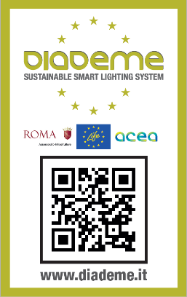

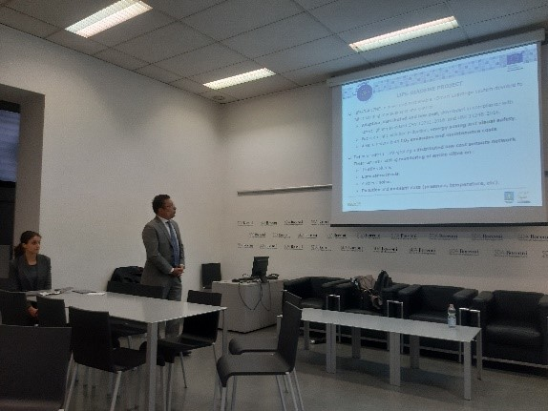

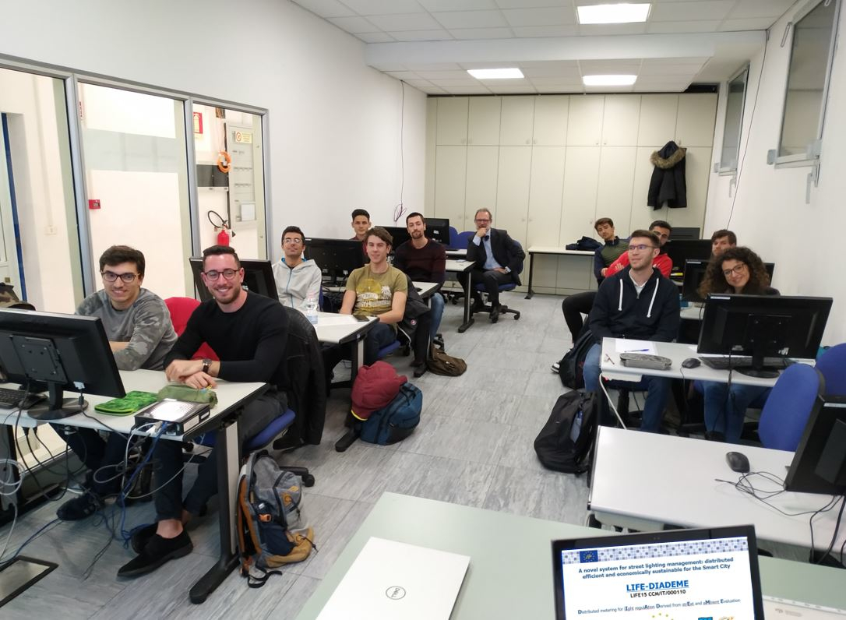

|  |
| --- |
| **DIADEME Workshops with the "Order of the Engeneer"**  In the last two years Reverberi Enetec, Coordinator Partner of the **LIFE-DIADEME** project, has been organizing a **Training Seminar** in collaboration with the **Order of Engineers** of some Italian Provinces on the issue "**Smart Lighting and Smart City**". It's considered almost a travelling workshop. The aim of the Seminar is to provide participants with the key elements to assess the convenience, energy savings and operational benefits in the adoption of the adaptive lighting within a Smart City project. As a Best Practice it is presented the system developed in Rome for the DIADEME project, an innovative application that allows a significant energy saving while ensuring the suitable lighting for the urban environment in different hours of the day, with every weather conditions and for different users: car drivers, cyclists or pedestrians.  Only in the first half of 2019 the Workshop was held in the cities of Rome, Milan, Bolzano, Catanzaro, Trani and Ragusa.  **Networking Activities and Cross Dissemination**  One of the dissemination activities envisaged by the DIADEME project is to exchange experiences with other EU financed projects, useful for sharing information about technologies and solutions applied, regulations and standards to comply with or to participate in the creation of common EU guidelines on dynamic lighting.  In 2017 DIADEME experts participated, in Cesena, in a Workshop promoted by the Interreg **DYNAMIC LIGHT** project committed to the creation of small pilot sites using adaptive light technology.  On 6 June 2019, **Eng. Paolo di Lecce and Eng. Andrea Mancinelli**, head and project manager of **DIADEME** project, presented the adaptive lighting system installed in Rome during the Final Conference of the **Life-DYNAMAP** project, committed to the creation of a system of acoustic dynamic mapping, using a network of low-cost sensors to detect in real time the acoustic impact generated by road infrastructures. It was really appreciated the possibility to have common future development on research and applications, while DIADEME was well considered for the technological solutions adopted.  The 11 July 2019, in Milan, DIADEME experts participated in the Mid-Term Conference of **Life** **PrepAIR** project, whose partners, Region and ARPA from many Regions in Northern Italy (Lombardy, Piemonte, etc.), proposed effective actions for the improvement of air quality in the Padany Plain. |







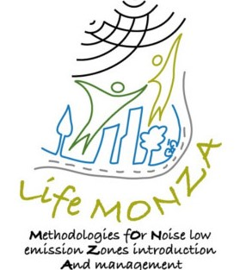



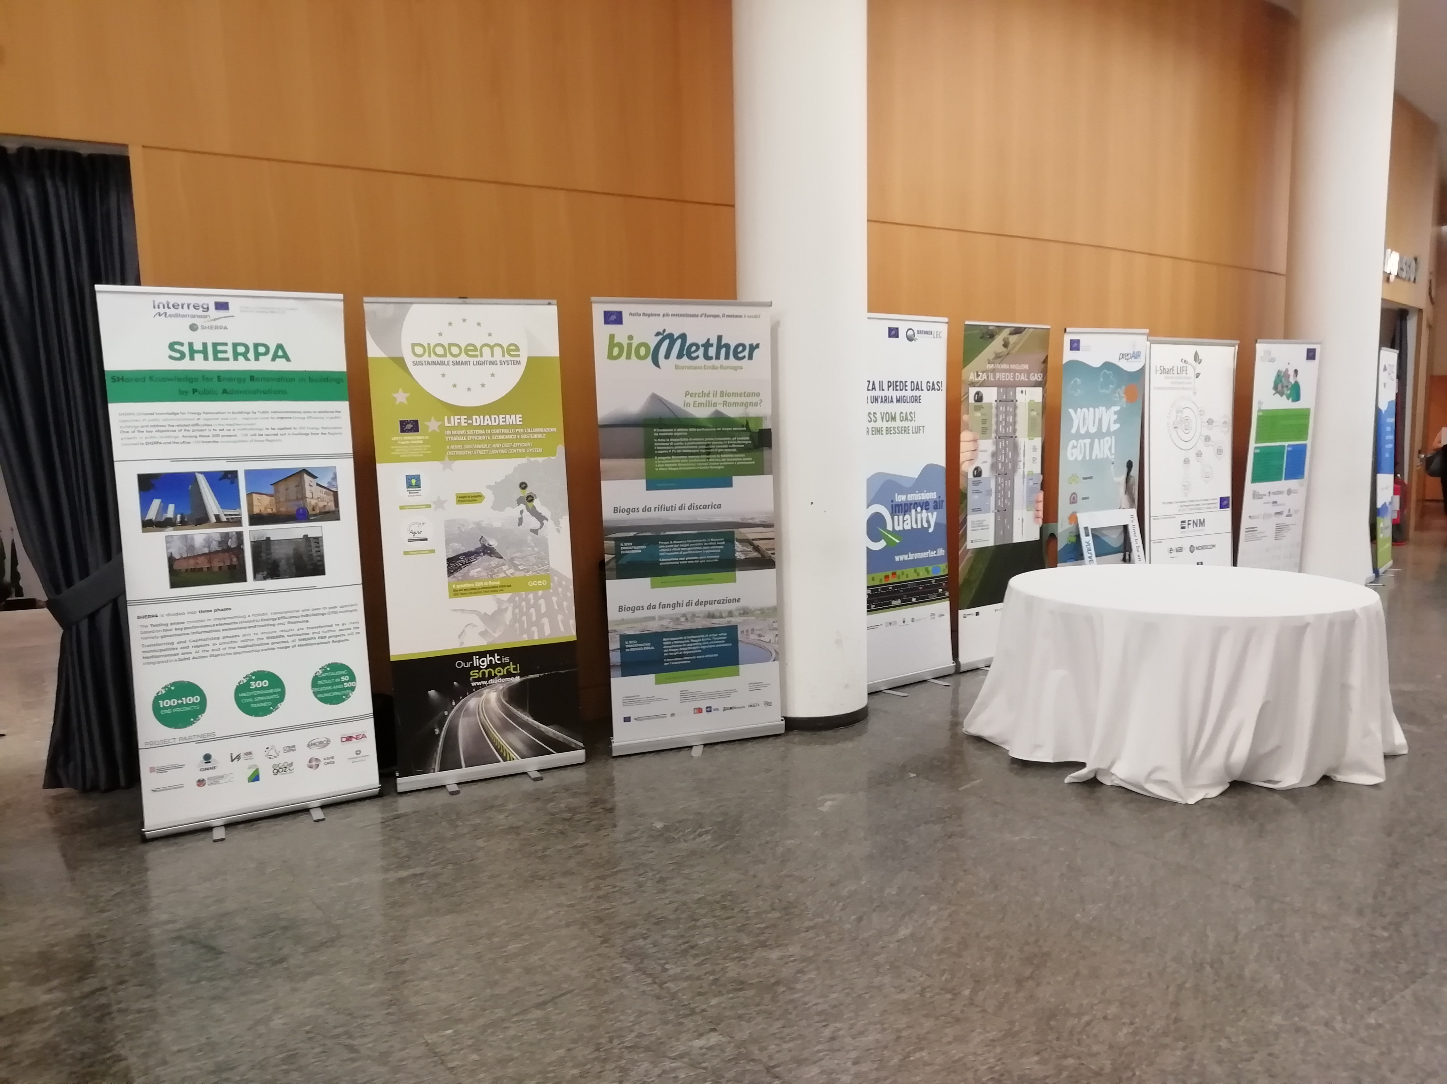

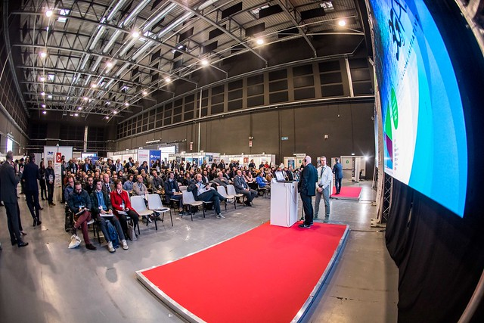

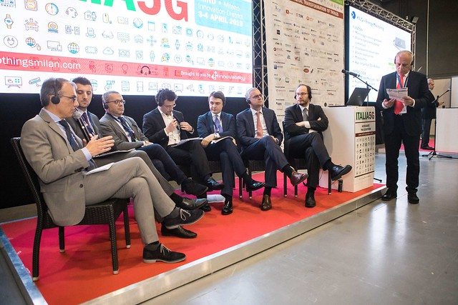

|  |
| --- |
| Finally, during the first half of 2019, there were some meetings with experts from the **Life-Monza** and **Life-Harmonica** projects, both working on noise monitoring. The output **Harmonica Index** was really important for the realization of the technology at the base of the sensors tested in DIADEME System for monitoring city noise.  **IOThings. Milan 3/4 April** **2019**  On April 3 and 4, "**IOThings**" was held in Milan, the most important Italian event in the field of Internet of Things technologies, a possible evolution of Internet network to increase the intelligent use of data communication. **Eng. Paolo di Lecce**, Managing Director of Reverberi Enetec and head of the Life DIADEME project, took part in the Round Table "**IoT Technologies for Energy Efficiency in Public and Private Lighting**".  Becoming "Smart" is the ambition of many cities aiming to develop innovations to improve the quality of life of their citizens. Smart lighting not only enables cities to become more energy efficient, more sensitive and adaptable to citizens needs, but can also promote sustainability because urban spaces become safer and more comfortable. With the support of Universities and Research Centres such as ENEA, the discussion addressed the topic by touching on the key points of the question:   * How cities provide additional services and infrastructures through smart lighting systems to improve quality of life. * Analysis of the applicable management models for the acquisition and control of strategic data supplied by the lighting infrastructures. * IoT lighting solutions for cities, business buildings and industrial areas.   **Eng. Di Lecce** presented the solution provided by the **Life-DIADEME** project, which is being completed in the Rome EUR district, one of the very first cases in Italy and Europe of Public Adaptive Lighting at the service of Smart City.    **Next Events:**  **DIADEME at Barcelona Smart City Expo World Congress (19/21 November 2019)**  Life-DIADEME is going to participate, from 19 to 21 November 2019, in the Barcelona Smart City Expo World Congress with its own space and organizing an Informative Seminar on public road adaptive lighting.  With more than **20.000 visitors**, **800 exhibitors from 150 Countries** and **400 speakers**, it is considered the world most relevant event on **Smart City and IoThings**, reference point for everyone is working to foster the sustainable improvement of the urban environment.  See you in Barcelona.  **DIADEME at Ecomondo Rimini, International Exhibition on Circular Econony (5/8 November 2019)**  Life-DIADEME is taking part, from 5 to 8 November 2019, in Ecomondo, the International Exhibition in Rimini, with its own Stand.  With more than **80.000 visitors**, **1.000 exhibitors from 66 Countries** and **150 Seminars and Conferences with 1.000 speakers**, it is the Italian crucial event on **Circular Economy and Sustainable Development**.  See you in Rimini. |

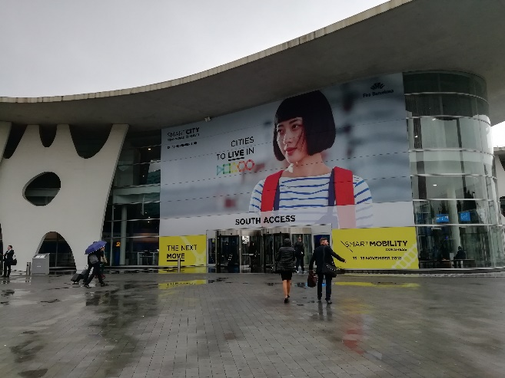

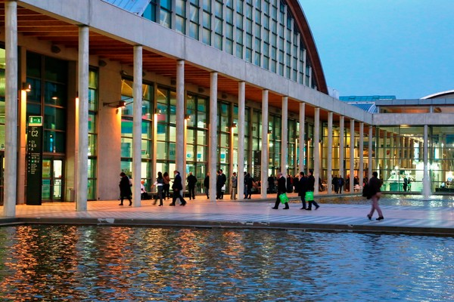

**Diademe Partners:**



**Reverberi ENETEC Srl**

**Gruppo MPES**Via Artigianale Croce, 13  
42035 Castelnovo ne’ Monti, RE

**www.reverberi.it**

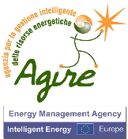

**A.G.I.R.E. Srl**Piazza Sordello, 43

46100 Mantova

[**www.agirenet.it**](http://www.agirenet.it)